AAUW some NEWS
News & Views from the
West Chester – Chester County PA Branch
wccc-pa.aauw.net

Volume 61, Number 1
September 2016

The AAUW West Chester and Chester County Branch
Pot Luck Dinner and Meeting
Spreading the Light
Barbara Price, Public Policy Chair

Wednesday, September 14, 2016
6:30 – 8:30 p.m.
Grove United Methodist Church

Join us for our delicious pot luck dinner and an inspiring start to our AAUW branch year. Barbara Price, Public Policy chair for AAUW-Pa., will speak to us about AAUW’s unique position to Spread the Light of public policy and leadership. Come and discover what you can do to shine a light in the darkness at both the national and local level in this critical year.

Barbara Price was Executive Director of the New Jersey Coalition for Battered Women for twenty years. She has had extensive speaking experience at conferences, on TV and on the radio. She was able to achieve significant changes in how government systems responded to victims of domestic abuse.

Barbara has held AAUW board positions at both the state and the local level. She has done presentations on At Lease with ERA and marched in Washington for the amendment. She has also served on the Bucks County Commisioners Advisory Council for Women and on the Pennsylvania Commission for Women as well as being active with many other advocacy groups. We are delighted and fortunate to have Barbara Price as our September speaker. (See page 11 for details)

Directions to Grove United Methodist Church, 490 West Boot Road, West Chester, PA 19380: From West Chester, take Route 100 North to Boot Road, turn left, and go toward the intersection of Boot Road and Whitford Road. The church is on the left before you reach the intersection. Find additional direction information at www.grovechurch.org or 610-696-2663.

Contents
Letter from the President | 2 | Gateway to Equity Award: Phoenixville Women’s Outreach | 5 | Mission & Members | 8
Fund Raising | 2 | Public Policy & Legislation  An Afternoon with Lisa Maatz | 6 | Board Meetings | 9
Afternoon Retreat | 3 | Harriet Jarosh Environmental Education Fund - 2016 Envirothon | 7 | SIG’s | 9-10
2015-2016 Accomplishments | 3-4 | Annual AAUW State-Wide Summer Retreat | 7 | Pot Luck Supper invite | 11

Letter from the President
Hello Members,

As I write this on a hot August afternoon, I can hear a chorus of cicadas outside. For me, the cicadas’ song is the harbinger of fall when we will be back to the Branch activities that kept us busy last year. So what will September bring to the West Chester-Chester Branch of AAUW?

- We will return to monthly newsletters thanks to the hard work of Nancy Rumfield, Norma George, and Toni Gorkin. I want to thank Tamara Hollins for all her years in helping to put out the newsletter.
- On Wednesday, September 7th, we will hold our annual Afternoon Retreat. You are all invited to a lively session exchanging ideas for increasing and maintaining membership and for encouraging greater involvement in our Branch.
- Speaking of greater involvement, Sue Johnston will head up the T.I.G. (Travel Interest Group) until she moves to State College, but we need someone to volunteer to replace her. We have been missing the fun day trips that Sue arranged for us in past years. Please step up and talk to Sue.
- On Wednesday, September 14, we hold the annual Pot Luck Supper and the first meeting of the year. Members will contribute main dishes, sides and salads, and desserts --- always yummy! (See the article in this newsletter for assignments.) After dinner, Barbara Price, wearing her new hat as Co-Chair of the PA State Legislative and Public Policy Committee, will speak to us on leadership and activism or “Spreading the Light”.

The Board has been busy this summer. Mimi Jones, our program V.P., has spent the summer arranging for some stimulating programs for our monthly meetings. Peggy Staarman, membership V.P., has maintained the membership data base for our branch and has come up with ideas for boosting our membership. Anne Anderko (a new grandmother!), treasurer and fundraiser has organized our first fundraiser. (See article in Newsletter). Jennifer Schultz and our new secretary, Eva Kaufmann, attended the State Retreat in Lewisburg, PA. (See Newsletter article.) Sandy Alexander has done her usual great job editing the Handbook. I have been getting my ducks in a row for this year’s activities as well as learning to update the Branch Website (wccc-pa.aauw.net) ---with Sandy Alexander’s help.

So, with the help and advice from you all, the members, we are ready to embrace the year ahead. Our collaborative efforts are why we are still a vibrant branch after 58 years.

Barbara Lathroum

Fall Fundraising – Pecans!

It is that time again to raise money for our organization! As I have mentioned in the past, only $16.00 of your dues goes back to the branch. With that said, I hope you will take the time to look at the Pecan Sale that we will be running this fall. Remember, the money we raise will go to support so many worthwhile programs for girls and women!

Back in 2011, we sold pecans and due to its success, we are bringing this fundraiser back. You will be able to choose from plain jumbo sized pecans for baking and all kinds of candied pecans from cinnamon, caramel, chocolate and more packaged in attractive gift giving bags ready for the holiday season. An order sheet and information will be e-mailed soon and orders will be taken up to Oct. 7. I will distribute orders at the Nov. 16 meeting. I encourage you to offer your friends and family the opportunity to support this fundraiser.

Thank you for your support!

Anne Anderko & Donna Golden
Fundraising Co-chairs

Afternoon Retreat
September 7, 3:30-5:30 PM
Grove United Methodist Church,
Room 204

What is the Afternoon Retreat?
I promise there will be no trust exercises or singing of “Kumbaya.” The Afternoon Retreat is simply a meeting of any and all of our members to plan Branch priorities for the coming year. This year, we would like to adopt some ideas for increasing and maintaining our membership. In addition, we need ideas that encourage greater involvement of our members, thereby developing a larger pool of leaders within our branch.

Fran Pierce and I will be leading the meeting. We invite not only Board members but ALL of you to attend. Our Branch needs not only new members but fresh ideas to build membership and greater participation. We would like to encourage some of our newer members to participate in this meeting. You can tell us what drew you to join and what you would like to see more of. Would you like to see more follow-up after joining? Would more social activities or more activism or more volunteer opportunities keep you and other members more involved?

Here is how I envision the Retreat:
- Introductions and Snacks
- Small Group Brainstorming:
Attracting New Members
Encouraging Member Involvement
- Coming together to formulate a Plan for Board approval.
- PIZZA and salad 5:30 - 6:00

Everyone is welcome to stay for the Board Meeting from 6:30-8:30 pm

2015-2016 Accomplishments
Sue Johnston
We can be proud of our accomplishments for the 2015-2016 year. We had seven wonderful programs that were well attended in addition to our September Potluck, December Holiday Party and May Banquet. Members attended state and district AAUW meetings, including the Summer Retreat (tonya thames-taylor), the Eastern District meeting (tonya thames-taylor, Barb Lathroum, and Sue Johnston), and the State Convention (Barb Lathroum).

Accomplishments include:
- Support of our Gateway to Equity awardee – Legal Aid of Southeastern PA- with donations collected at the Holiday Party and February Brunch

- Alice Lawson Scholarship awarded to Kim Bach who we hope will join us at the September potluck.

- Start Smart Workshop held at WCU with 63 participants led by tonya thames-taylor and Jennifer Schultz. A repeat is planned.

- Using the Harriet Jarosh Environmental Education Fund we were a sponsor of the Chester County Envirothon that was held May 4th and 5th at Hibernia Park. The fund also purchased a water shed model to be shared by Chester County Schools.

- We were one of the sponsors of the report on State of Women in Chester County and many of us were present at the roll out. Information from AAUW was included in the report. We also had an AAUW display.

- We again were a sponsor for GETT and many of our members volunteered. There was record breaking attendance this year.

- We were a sponsor of “Your Vote is Your Voice Campaign” conceived by the Chester County Faith-Based Coalition for Voter Registration targeting women in CC who are not registered to vote.

- We had two successful fund raisers, Snack’n and a Pampered Chef party.
2015-2016 Accomplishments (continued)

- Eleven Members volunteered at the Chester County Food Bank packing 480 boxes of food for senior citizens

- Six members participated in a three part self-defense workshop

- We participated in the 2016 Volunteer Fair sponsored by the Chester County Library

- In addition there were many successful FIG events, Lit group meetings and a revival of women’s social bridge

Our new officers for the 2016-2017 year were installed at the banquet. They are:

- President - Barb Lathroum
- Co-Vice Presidents for Program - Mimi Jones and Bonnie Friedman
- Vice President for Membership - Peggy Staarman
- Finance Officer - Anne Anderko
- Secretary - Eva Kaufman

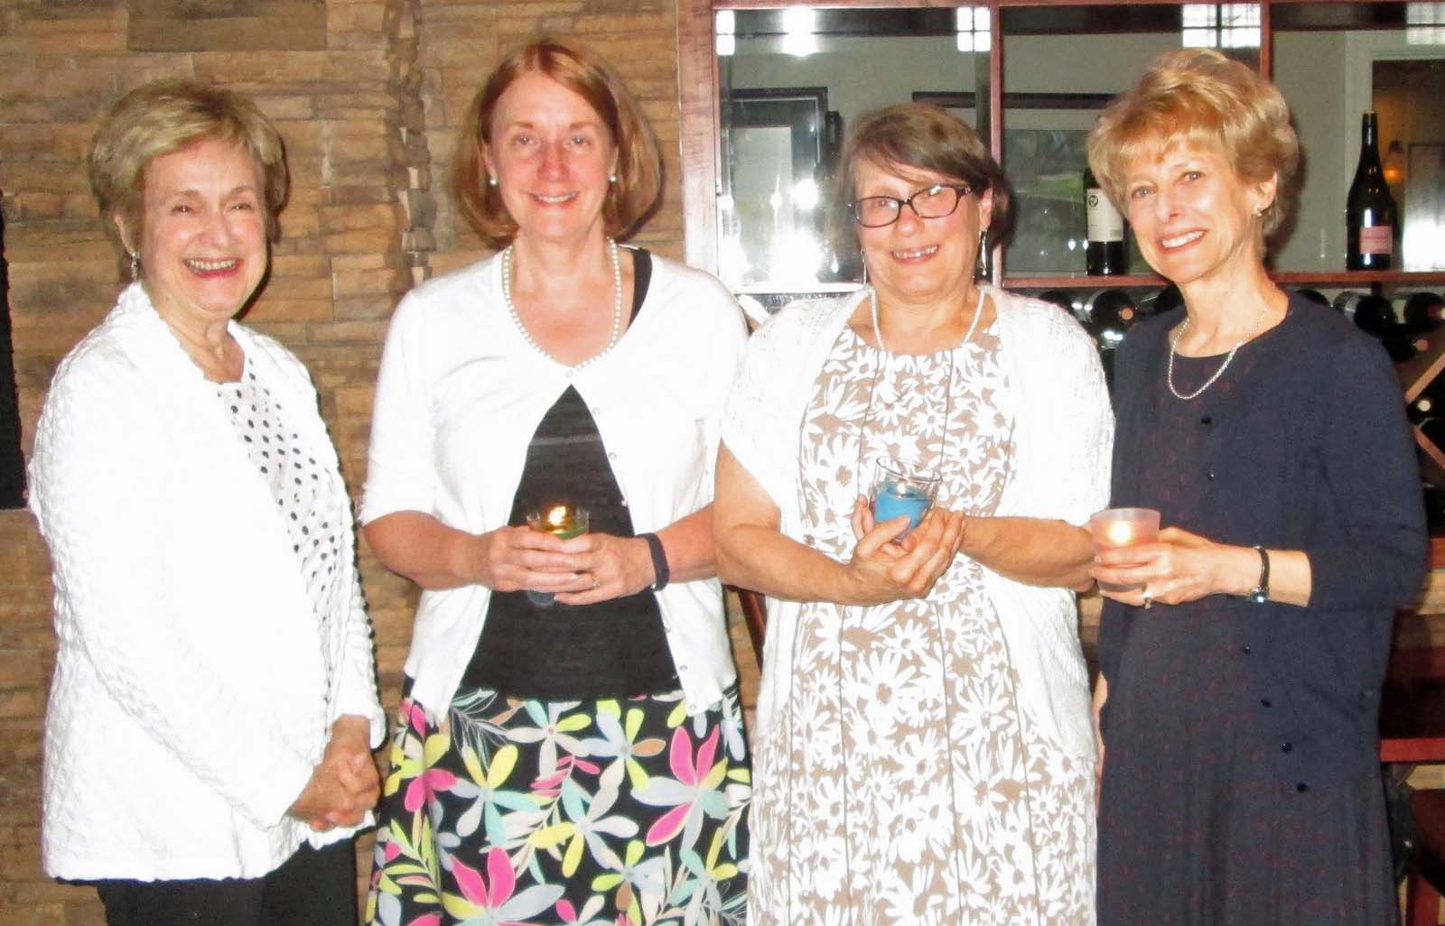
Our new officers: Mimi Jones ( Program VP), Anne Anderko (Finance Officer), Barb Lathroum (President), and Peggy Staarman (Membership VP).
Awards were also presented as follows:

- Outstanding Women - Anne Anderko
- Member Making a Difference - tonya thames-taylor
- Peg Anderson Award - Jane Schultz
- Gateway to Equity - Phoenixville Women’s Outreach, accepted by founder and director, Cheryl Messere
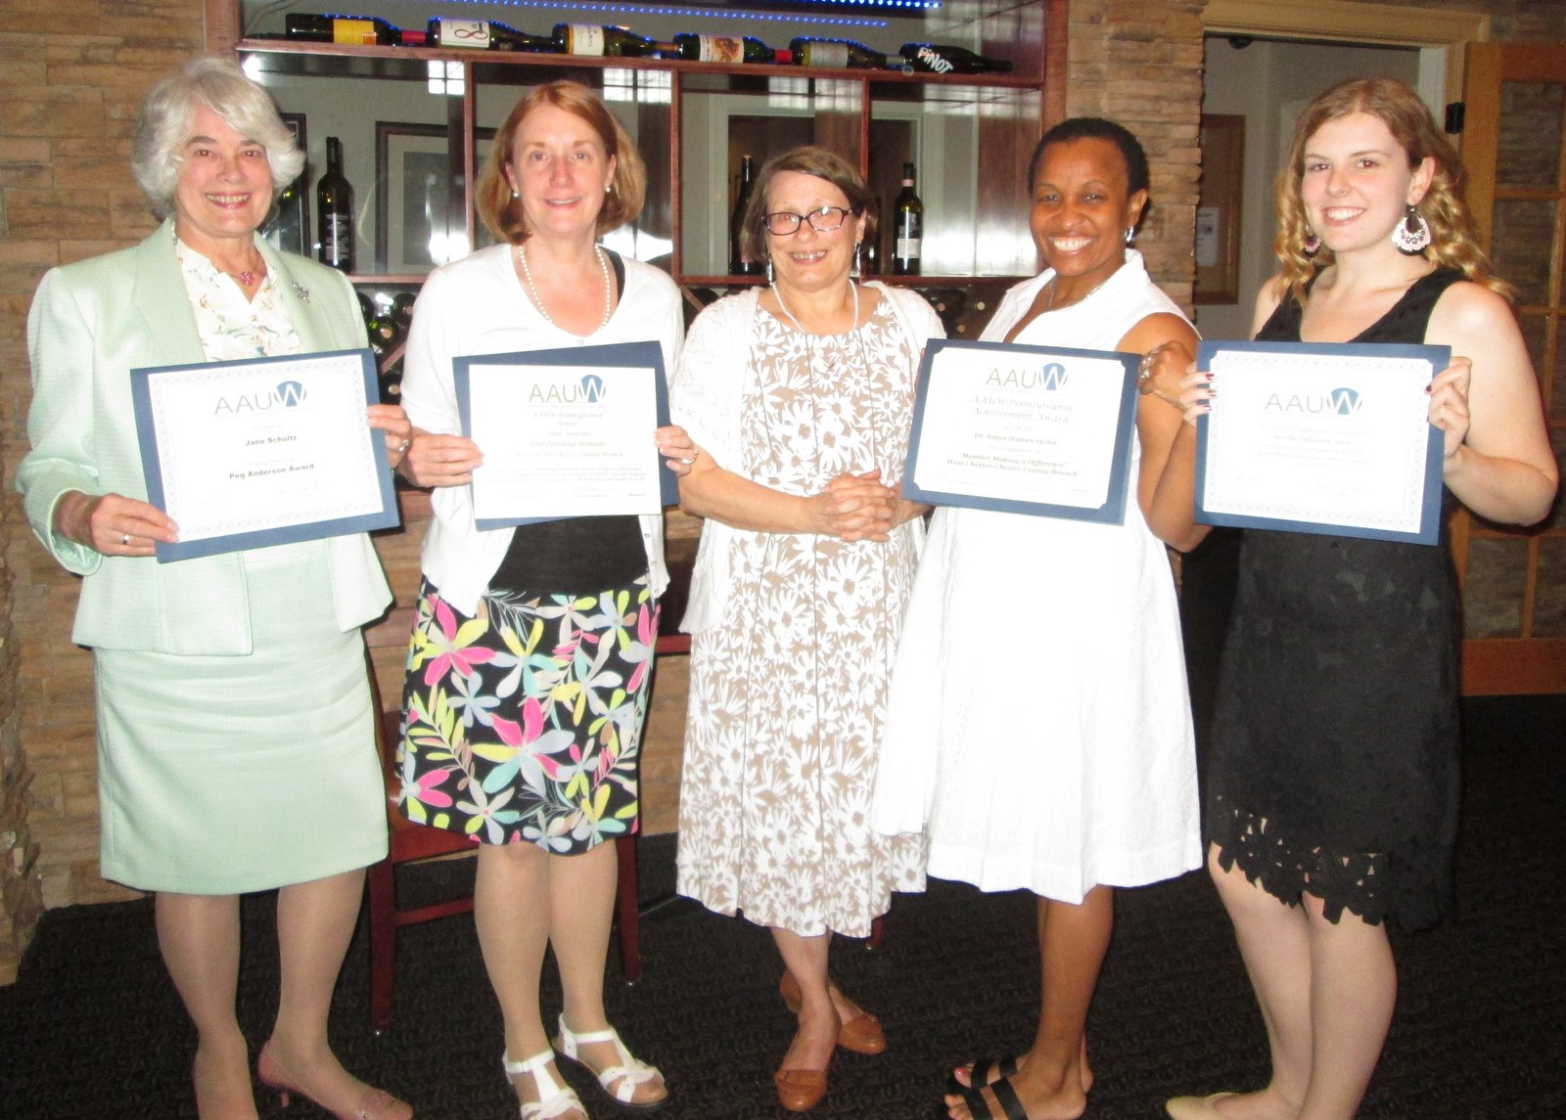
Award winners from left to right: Jane Schultz (Peg Anderson Award), Anne Anderko (Outstanding Branch Member Award), Barbara Lathroum, tonya thames-taylor (Member Making a Difference Award), and Jennifer DiSimone-Jewell (President of student affiliate at West Chester University).

We congratulate our new officers and awardees.
Our nominating committee did a great job this year recruiting capable members for our Board of Directors. They tried very hard but were unable to recruit a president-elect. Barb Lathroum is very capable of leading the organization on her own but it is best to have someone learning the position. I can attest to the fact that being president of this organization is a rewarding experience and not difficult. The board and committee chairs are all self-starters and really pitch in to help. If you are interested in this position please contact a board member.
Thank you all for the help and support this year and making life easy for me as president.

Did you know?
Because our members are so important to us,
we want to keep in touch. Do you know of a
member who needs to receive a get well note
or card of support?
Please contact our Corresponding Secretary –
Rosemary MacDonald
rosemary.macdonald@verizon.net with the
information.

Gateway to Equity Award to
Phoenixville Women’s Outreach: The House

At the May Banquet, we listened to Cheryl Messure talk about The House and its mission when she accepted the Gateway to Equity Award on behalf of the Phoenixville Women’s Outreach. On July 13th, Mary Smith, Peggy Staarman, Mimi Jones, and Barbara Lathroum paid a visit to the House to learn firsthand about this transitional housing program for homeless, low-income, single women. Cheryl Messure and the resident director, Lana Ringer, welcomed us in through The House’s cheerful yellow door to a cozy living room where we listened to the story of The House’s creation.

Did you know that of the 600 homeless in the Pheonixville area one-third are women? There exist shelters for women with children but none for single women. The House is helping to fill that need. The House is not just a shelter for these women but a support program through which the women receive access to counseling, skills enhancement, and financial advice in order to achieve self-sufficiency. Moving from “crisis to independence” is the goal.

When the Women’s Outreach acquired the row house in November 2014, a bevy of volunteers painted, patched, and re-floored the building so that The House could start accepting women by January 2015. Donations of furniture, curtains, appliances, and a computer have made the House a warm and cozy, safe place for six women to acquire the skills and the confidence to succeed on their own. Downstairs, there are a living room, TV room, dining room, kitchen, and bath. Upstairs on the 2nd and 3rd floors, there are two single bedrooms, two double bedrooms, and another bath. Through donations, everything is provided for the women while in transition: beauty supplies, necessities like toilet paper and detergents,
and food.

How can our branch help? The House appreciates donations as listed below:
- Gift cards to Giant Food, Redner’s, Staples, Target or K-Mart
- Laundry detergent, Dawn dish detergent, dryer sheets
- Tissues, toilet paper, paper towels
- Hair products (including those designed for black hair), hairspray, lotions
- Hair brushes and combs
- Folger’s coffee, flash drives for computers, printer ink (Brother LC101 black, LC103 color)
- Tall kitchen plastic bags, one-gallon Ziploc bags, Clorox or Lysol wipes
- Stamps, flashlights, light bulbs (40, 60, 3-way)

When you see a 2-for-1 sale on any of these items, think of The House and bring the items to the next meeting. The House is also selling $5 Boscov’s shopping passes for October 21. Mary Smith is our contact member.

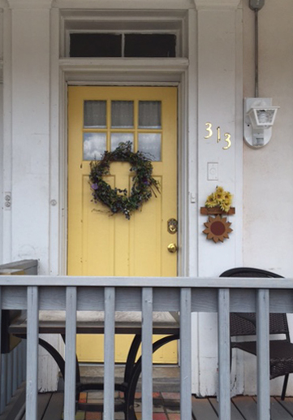

Public Policy & Legislation
An Afternoon with Lisa Maatz
Cathy Palmquist

Sue Johnston and Cathy Palmquist joined with about 65 AAUW members and affiliates, (League of Women Voters, Planned Parenthood), in July in Langhorne to hear Lisa Maatz, AAUW Vice President of Government Relations and Public Policy, Political Strategist and Analyst, and AAUW’s top lobbyist. Lisa had just come from the Democratic National Convention, and attended the Republican National Convention the week before. In her non-partisan remarks, Lisa shared some of her impressions and perspectives on the conventions (She has been to 6!)

“In Cleveland, folks were unhappy, the convention hall was never full, and Cleveland itself, while clean and pretty, was a ghost town.” She thinks part of the reason was that security scared people away; “there were barricades everywhere.” AAUW was not the only non-partisan organization in attendance, but many AAUW affiliates stayed away.

Lisa is particularly interested in women’s issues in the 2016 election, and a focus on younger women. “Getting them out to vote is a challenge. In some places, students are still told they cannot vote in their college town or they will lose their student loans - not true!” At both conventions, Lisa met with AAUW members. Most of them at DNC were young women. She also commented that Republican women feel their party has left them behind, and they want to bring it back.

“At the DNC, the entire convention was carefully orchestrated to engage all attendees, which it did.” Lisa saw people from a variety of faiths, and “there were ‘real’ people who gave amazing speeches,” she noted, citing in particular Mr. Kahn. Due to the standing room only crowd, there were folks always looking for seats. Lisa had one seat next to her, and she waved to a man who seemed to be looking. It turned out he is Jared Hill, the man who broke the news of Malania Trump’s plagiarism of Michelle Obama’s speech. She said the Green and Libertarian parties and Independents make up about 15% of the voting population. “Look for how many folks are still supporting those candidates by Labor Day. If it’s still 15%, that may not be good for Hillary Clinton.”

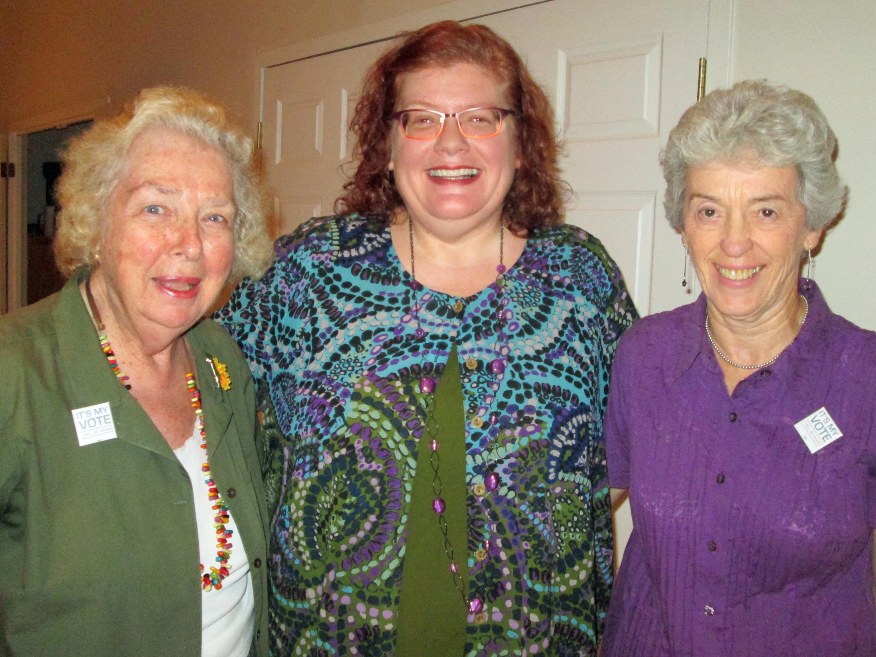
Left to right: Cathy Palmquist, Lisa Maatz, Sue Johnston during visit about recent government relations and public policy events.
Lisa said it's more important to get people registered and voting, rather than trying to change people’s minds about candidates. “Sometimes we feel no one is listening, but we must work with both (major) parties.” And as Rep. Keith Ellison of Minnesota said, “not voting is not a protest, it’s a surrender,” she said in conclusion.

Two Minute Activist

Don’t forget your commitment to be a frequent

Two Minute Activist. Make your voice heard in

Congress regarding education, economic security,

and civil rights. Using our website (under AAUW

Links) is so easy!

Call for donation: Laundromat Library League
Our chapter supports the Laundromat Library League (LLL) which places children's books in local laundromats. There is a need for "board books" (cardboard books for toddlers). Contact Terry Houle at 610-269-7271 if you wish to donate.
2016 Chester County Envirothon
AAUW Harriet Jarosh
Environmental Education Fund
Sandy Kwisz

The AAUW West Chester-Chester County Harriet Jarosh Environmental Education Fund supports environment education and activities in the Chester County Schools. This year the fund sponsored the Chester County Envirothon and the purchase of a Watershed Model to be used as a hands-on education tool in classrooms.

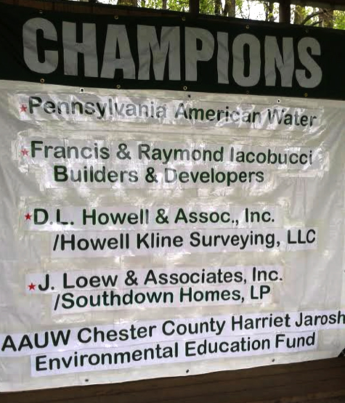
AAUW Chester County Harriet Jarosh Environmental Education Fund was a sponsor of the 2016 Chester County Envirothon.

I had the pleasure to represent our branch as one of the sponsors of the 2016 Chester County Envirothon. This annual environmental education program is supported by the Chester County Conservation District and held May 4th and 5th at Hibernia County Park. The event is the culmination of weeks of classroom study helping students understand the natural environment and their role in it. This year’s theme was Invasive Species.

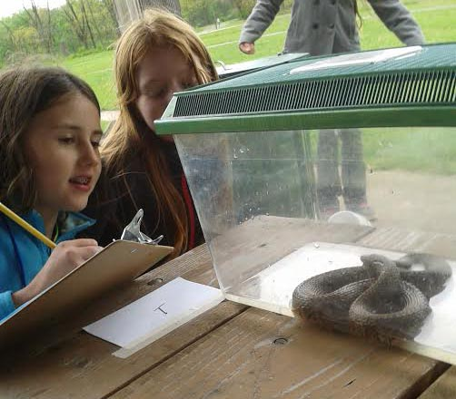
Envirothon participants

I was impressed by the students’ knowledge as the worked in teams to identify plants and different species. Although it was a cold and wet spring day, it did not diminish the students’ enthusiasm.

Annual State-Wide AAUW Summer Retreat
Jennifer Schultz

On July 16, Jennifer Schultz and Eva Kaufmann traveled to Lewisburg to attend the annual state-wide AAUW Summer Retreat. Jennifer reports that there were many great sessions focusing on topics our branch is tackling. The morning session taught membership development – and highlighted the many resources on the national website, http://www.aauw.org/resource/relational-recruitment-method/.

The afternoon session challenged members to look at improving diversity and inclusion – and the implicit biases that can lead to an unwelcoming environment for new potential members. They emphasized the Diversity and Inclusion Tool Kit as a resource for local leadership and members to learn more.

For additional information see the article on the AAUW-PA website, including a PowerPoint presentation from the national office
https://aauw-pa.aauw.net/meetings/retreat/

AAUW Mission Statement
AAUW advances equity for women and girls through advocacy, education, philanthropy, and research.

Norma George Newsletter Co-Editor
610-872-7567 ngeorge@cheyney.edu

Nancy Rumfield Newsletter Co-Editor
610-399-0388 nrumfield@gmail.com

Toni Gorkin Newsletter Co-Editor
610-363-7627 tgorkin@comcast.net

Newsletter email aauwsumnews@gmail.com

Barbara Lathroum Branch President
610-321-9783 blathroum@gmail.com

Mimi Jones Program Vice-President
610-269-9162 Danandmimi1@verizon.net

Peggy Staarman Membership Vice-President
610-269-4866 peggstaar@verizon.net
Eva Kaufmann Secretary
610-793-3809 ekaufmann1@gmail.com

Anne Anderko Financial Officer
484-885-4943 ananderko@msn.com

Branch Website wccc-pa.aauw.net

Membership Outreach

Your Records with the National Association can be accessed by contacting:
--Helpline Phone (800) 326-2289 or
--Internet and email: The website for national AAUW is http://www.aauw.org/.
You’ll need your membership number, which can be found on the address label of the Association publication (Outlook).

About Member News

If you have news that you would like to share with our organization, we would love to hear about it. This may be your accomplishments, research, performances, etc. Please send detailed information to the newsletter editors:
aauwsumnews@gmail.com.
Thank you for sharing!

Membership News
Peggy Staarman (Vice President for Membership)

The branch would like to welcome our two newest members. Marcia Robinson, a friend of Norma George and assistant director of human resources at Cheyney University, joined the branch at our May banquet. Cheryl Messere, who spoke to us about the Phoenixville Women’s Outreach and The House at the banquet, also joined. A few of us had the pleasure of touring The House with Cheryl this summer. Our branch is supporting this community effort to provide housing, counseling, and vocational opportunities to homeless women.

The branch presently has 75 members. The board encourages all members to attend a Branch Retreat held at Grove Methodist Church on Wednesday, September 7 from 3:30 to 5:30. Membership growth, retention, and participation will be the focus of the retreat. We hope you will suggest ways to address all of these concerns. If you cannot attend, please contact me (peggstaar@verizon.net) with your ideas. Thank you so much!

Interested in submitting an article or have information to share?

We need your News!

The co-editors of AAUWsome News, are

delighted to bring you this issue of the

newsletter, but … We continue to need input

from members!! Please send articles as Word

documents. Forward your news articles to the

gmail account: aauwsumnews@gmail.com,

indicating the topic and month in the subject

box and cc the President. This is a shared

account, so the co-editors can access your

email and keep their work or personal

mailboxes from getting filled. It also makes

collaborating easier.

Remember that articles for a given month of

the newsletter are due on the 10th of the

preceding month. Please provide all necessary

information with your submission.

Guidelines for AAUW some

1. Deadline for articles is the 10th of the month prior to publication – e.g., October 10, December 10, January 10, etc.

2. Board will develop outline/plan for newsletter.

3. Copies of each newsletter article must be sent to the President and the President Elect.

4. Articles should be less then 340 words (1 column in 12 pt.) and sent as .doc (Word) files whenever possible.

5. Program information should be available for publication in the month prior to the event.

6. SIG information should be specific (when, where, leader, contact info., program or book).

7. Photos should be sent in .jpg format and should be the best quality possible. Leave cropping to the editors when possible. Be sure to provide names of the people and description of the happening in the photo.

8. Editors must keep newsletter to 10 pages or less (5 printed front and back).

9. Editors must consult with President or designee if newsletter is too long.

10. Editors and President will determine number of copies to be printed.

11. Board will review and decide list of Friends who receive printed copies.

12. The newsletter should go to the printer by the 25th of the month. Copies should include the Circulation Manager, Person who distributes the e-mail version, and, if requested, other named designees.

Help AAUW Save Money

Each year our editors put together informative, attractive, and news filled issues of our AAUW some newsletter. At current prices, printing and mailing costs exceed $1.50 a piece per issue. For several years, most of our AAUW members have received their copies via e-mail. If you are not already receiving AAUW some via e-mail and would be willing to do so, please contact Sue Johnston, sjwj77@verizon.net

Board Meetings

The next Board Meeting will be held on Wednesday, September 7th at 6:30-8:30 pm at the Grove United Methodist Church, room 204, following the Afternoon Retreat from 3:30 to 5:30 pm. (See article.) All Board Meetings are open to the membership.

Board Meetings are held on the first Wednesday of each month, 7-9 pm. Except for September and January, the Board will meet at West Chester University, Sykes Room 257. The board will meet at Grove United Methodist Church in January.

Special Interest Groups

Couples Bridge
A chair is needed. Please contact Sue Johnston, sjwj77@verizon.net if interested.

Women's Social Bridge
Do you want to spend some time with fellow AAUW members by playing social bridge once a month? We are in the process of choosing a day and time. Please contact Sandy Alexander at frau.salexander@gmail.com or 610-363-7467 for more information or to be added to our email list.

Book Groups:
AAUW branches are known for their book groups, and membership in a group often encourages continuing membership. The West Chester-Chester County Branch currently has two book discussion groups meeting in the day and in the evening at different times of the month.

LIT I: Daytime Literature Group –
Fiction & Nonfiction Book Group- Kay Phillips- khp65hp@verizon.net

Lit One meets the third Monday of the month during the day at member's houses. We read both fiction and non-fiction.

We will meet on Monday, September 19, 2016 at the home of Elaine Burgess at 15 Wild Flower Court, Gordonville, PA (717-768-0706)
at 1:00 pm for refreshments. Discussion starts at 1:30 pm. Eva Kaufmann will lead the discussion of Most Wanted by Lisa Scottoline. We welcome new members. Call or e-mail Kay Philipps if interested. Phone is 610-399-0697 or khphilipps@verizon.net. Kay Philipps

You can find the entire schedule for LIT I for the year on our webpage.
http://wccc-pa.aauw.net/files/2016/07/LIT_ONE_AAUW-2016-2017.pdf

LIT II: Evening Literature Group –
Literature II - Fiction & Nonfiction Book Group -Jean Speiser - JeanSpeiser@gmail.com

Lit Group II meets on the third Wednesday of the month at 7:00 for conversation and nibbles, with the discussion starting at 7:30. We usually read fiction but also occasional non-fiction.

On September 14 we'll discuss Defending Jacob, the story of an assistant district attorney in a Boston suburb whose son is accused of killing a classmate. Although “Booklist” says that the author, William Landay, "raises personal and painful ethical issues pertaining to a parent’s responsibilities to a child, to a family, and to society at large" it's not a stuffy moral treatise but a fascinating and gripping book.

We always welcome new members so please join us to see if we're a good fit for you. There's no commitment. Jean Speiser sends out reminders about a week in advance, so let her know if you are interested in getting those reminders. You can reach her at JeanSpeiser@Gmail.com.

In October we'll be reading The Millionaire and the Bard about Henry Folger and his relentless pursuit of the Shakespeare First Folio.

Note: the November 2016 meeting will be held on the 9th of November not the third Wednesday.

FIG (Food Interest Group)

This group dines around either at members’ homes or at restaurants. The group meets on weekends, usually on Saturday evening or Sunday for brunch. Couples (unless otherwise specified) and singles, as well as new members, are welcome.

There are currently no events on the FIG calendar. Please contact Donna Eaves at 610-692-5277 or deaves@live.com if you are willing to host or co-host an event at your home or at a restaurant. If you are not currently a member of FIG and wish to be placed on the email invitation list, please contact Donna.

Great Decisions
For information contact Jacky Page at 610-359-9887 or jacquelinepage9@gmail.com

TIG (Travel Interest Group) –This group needs a leader. If you are interested in coordinating trips, please contact Sue Johnston at 610-363-8535; sjwj77@verizon.net

Craft Group:
Work on your own project or join us as we create items for the children at the Domestic Violence Center. Members could also knit or crochet hats or blankets for the children at the shelter. Please contact Jean Speiser at JeanSpeiser@Gmail.com or 610-738-3363 for additional information.

Needlework Group:
In the past there was some interest in a knitting group, but it never materialized. This proposed group would include all forms of needlework – knitting, crochet, embroidery, applique, quilting, needlepoint and any other needlework members would like to share. Meetings could be work sessions or members could share their work and techniques with others.

If you are interested in any of these forms of needlework or have some ideas on starting this group, please contact Norma George ngeorgester@gmail.com or Toni Gorkin tgorkin@comcast.net

POT LUCK SUPPER

Wednesday, September 14th
6:30 PM
Grove United Methodist Church
490 West Boot Road
West Chester, PA

Welcome
to the Pot Luck Supper & first meeting of the
West Chester - Chester County Branch of AAUW

Following dinner our guest speaker,
Barbara Price,
will speak on “Spreading the Light”

Ms. Price is the new AAUW-PA Co-chair of the
Legislative & Public Policy Committee

Branch Members should provide a dish to serve 6 – 8
A – H – Entrees
I – P – Desserts
Q – Z – Salad or Side Dish

402 Edgewood Drive, Exton, PA 19341.

September 2016 Newsletter

September 14, 2016 – Pot Luck Supper
wccc-pa.aauw.net

AAUW Mission Statement
The AAUW advances equity for women and girls through advocacy, education and research.
AAUW Vision Statement
AAUW will be a powerful advocate and visible leader in equity and education through research, philanthropy, and measurable change in critical areas impacting the lives of women and girls.

AAUW West Chester – Chester County Branch Vision Statement

The West Chester-Chester County Branch will
- Actively recruit members who support Association goals.
- Nurture these members through active Interest Groups, through monthly meetings with
intellectual and social merit, and through member support.
- Sponsor at least one project per year with volunteers and with funds to promote Association and branch goals.
- Sponsor at least one local scholarship per year for a nontraditional student
- Support programs for training and self-development of branch members to promote
Association goals.
- Raise funds through community projects and member gifts to support Association goals.
**********
Since its first meeting in 1881, AAUW has been a catalyst for change. Today, with more than 100,000 members, 1,000 branches, and 500 college and university partners, AAUW contributes to a more promising future and provides a powerful voice for women and girls—a voice that cannot and will not be ignored.
www.aauw.org www.aauwpa.org wccc-pa.aauw.net

