AAUW some NEWS
News & Views from the
West Chester – Chester County PA Branch
wccc-pa.aauw.net

Volume 62, Number 5
June 2017

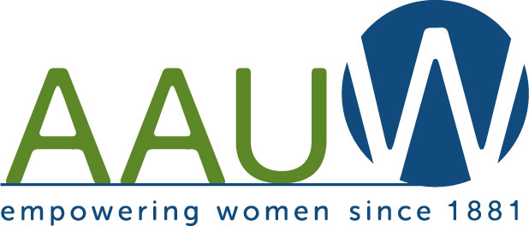

Annual AAUW West Chester - Chester Branch
May Banquet Held on May 10th
Recognition & Awards Given
Officers Presented

The Annual AAUW West Chester – Chester County PA Chapter banquet was held on Wednesday, May 10, at Timothy’s of Exton. Forty-seven members attended. After social time, dinner and dessert, the Gateway to Equity Award and other awards were presented.

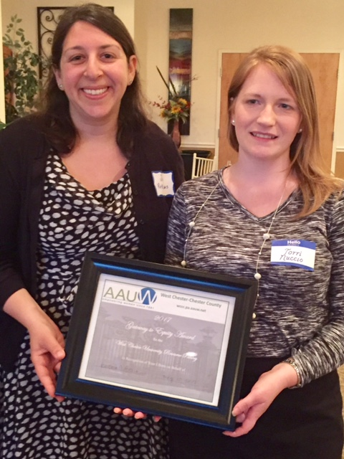
Jodi Roth-Saks and Tori Nuccio accepted the Gateway to Equity Award for the West Chester University Resource Pantry

A business meeting then was held, with acceptance of the April meeting minutes and the Treasurer’s Report on the Budget for 2017-18. Officers were introduced and elected.

A special thanks to Anne Anderko and others who assembled a “Pampered Spring Basket” that was raffled off, yielding $181.00 profit to the treasury.

You’ll find more banquet news in this month’s articles.

Contents

May Banquet | 1 | Alice Lawson Scholarship | 5 | Mission Statement, Newsletter Guidelines | 7-8
President’s Letter | 2-3 | New Officers Installed | 5 | Member News | 8
Gateway to Equity Award | 3 | Outstanding Women Award | 5 | Board Meetings | 8
Peg Anderson Award | 3 | Laundromat Library League | 6 | Members Special Notes | 9-10
Member Making a Difference | 4 | Local Opportunities: Get Involved | 7 | SIGs | 10-11

Letter from the President
Barbara Lathroum

Dear Members:

What a year! I thought I would begin my message to you with an accounting of our accomplishments.

- We joined with the Chester County League of Women Voters at Exton Mall registering shoppers to vote in the November election.
- We raised over $300 in gift card donations for our 2016 Gateway to Equity Award winner, The House in Phoenixville.
- We planned and presented a hands-on activity for girls attending this year’s G.E.T.T. (Girls Exploring Tomorrow’s Technology). Our branch donates $500 to this wonderful event each year.
- We held our 2nd annual “Start Smart” workshop in which college women (and some men) learned negotiating skills in order to narrow the pay gap between men and women.
- We contributed $1000 to the Chester County Envirothon, an annual county wide contest on environmental topics for public school students. Our sponsorship of this event is made possible by the Harriet Jarosh Fund for Environmental Education. The watershed model we purchased last year for environmental education in the county schools is still in service.
- We awarded a $1500 scholarship to a non-traditional undergraduate woman trying to complete a bachelor’s degree. This year’s Alice Lawson scholarship went Amanda Carilla, a junior studying early childhood education and raising a toddler son.
- We bestowed the 2017 Gateway to Equity Award to the West Chester University Resource Pantry which seeks to provide food, toiletries, school supplies and clothing to homeless students.

In his eloquent farewell address, President Obama stated, “We all share the same proud title: Citizen”. He went on to say that citizenship is what our democracy demands --“not just when there’s an election, not just when your own narrow interest is at stake, but over the full span of a lifetime.” Our branch’s programs this year reflected that our members take seriously our duties as citizens. One duty of a citizen is to stay informed. Barbara Price spoke to us about Getting Out The Vote; Susan Carty spoke about Voting Reform; Kara Rahn informed us about the workings of the Voter Services Office in Chester County; and Fran Pierce informed us about the effects of
vouchers, charter schools, and cyber schools on our public schools.

As AAUW members and citizens, we are committed to the empowerment of women and girls and to leveling the playing field for them. Tammy Williams spoke to us about the Women’s Summit in Washington last June in which women had a chance to talk about issues facing women and possible solutions. We heard how The Girl Scouts of America and the Chester County Intermediate Unit foster STEM educational opportunities for women and girls. Tia Brown of Cheyney University addressed gender and racial stereotypes with a successful campus action plan entitled “#MyLifeMyLabel”. All programs were designed to keep us informed as citizens.

I commend you, the members of our branch. Some of the most admirable contributions of our branch were and are carried out by individual members. Obama challenged citizens to “Show up. Dive in. Persevere,” and we have! Members showed up to demonstrate in Washington, DC, in Philadelphia, and in West Chester. We attended Fair District meetings to find out how we can put an end to the gerrymandering in Pennsylvania that undermines representative democracy. We attended forums on the affordable care act. Many of us dove into huddles which seemed to crop up everywhere. We spoke with congressmen and senators at the state and national level. We made phone calls and sent letters and postcards to those who represent us about issues affecting citizens. We are starting to pay attention to those who run our township, borough, and county. These are officials that make the biggest impact on our everyday lives. AND…..we persevere!

Your board already has ideas for next year’s meetings and projects. We will be meeting soon and throughout the summer. If you have not renewed your membership already, please do so promptly. You won’t want to miss what we come up with!

Barb Lathroum

Gateway to Equity Award to WCU Resource Pantry

This year’s Gateway to Equity Award was presented to the West Chester University Resource Pantry. The purpose and function of the pantry was explained by its co-chairs, Tori Nuccio and Jodi Roth-Saks. They pointed out the special needs of some students at WCU. Tori is the point of contact for students who are coming out of foster care, or are homeless. About 3800 students are attending on Pell Grants, but have needs beyond the scholarship who qualify for assistance. Jodi works from the Office of Service Learning and Volunteer

Services with work-study students earning their way through school. Many of these students do not have family resources to support them with common life needs, especially during breaks.

The Pantry started when Tori started to hear of needs for winter coats, shampoo, etc., and donations came to her office. Jodi described how the Pantry helps alleviate barriers to graduation for these students by providing:
- Food (including fresh produce)
- Clothing (e.g., winter apparel and professional attire for interviews
- Profession hygiene products

Support also includes skill building workshops with other groups on campus, such as resume skills, and one-on-one mentoring, and case management with staff, graduate social work students and other resources.

The idea is to help students in a holistic manner. Tori and Jodi explained the way students access the services and how the availability is communicated through the website, speaking to faculty meetings, free promotional dinners, etc. Their goal for 2017 is to help combat stigma and encourage students to use these services.

They expressed their appreciation for AAUW’s support for the Pantry. Information about making donations is at Pantry@WCUPA.edu.

Peg Anderson Award

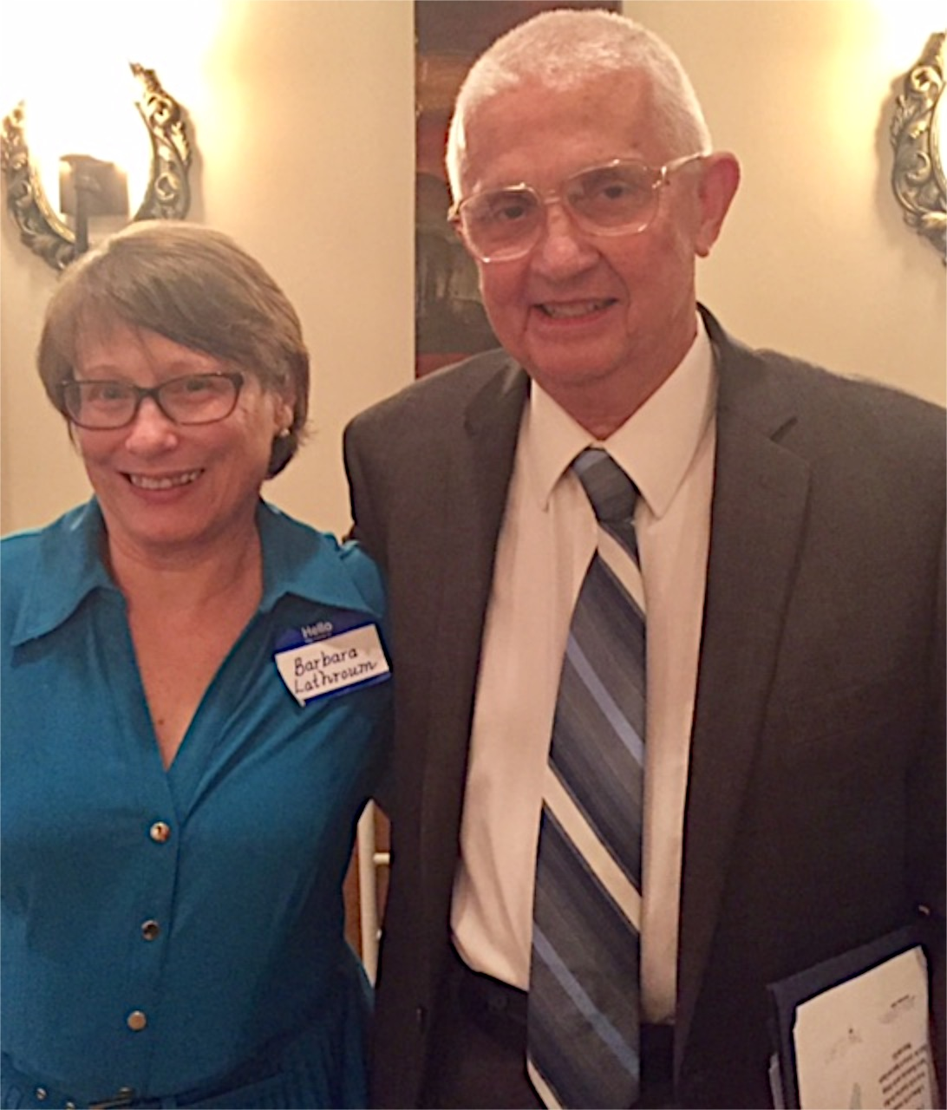
The Peg Anderson Award was presented to Yvonne Mae Peiffer, who passed away in December 2016. Yvonne was branch President in 1977-1979 and again in 2006-2007. During her forty-four years as a member she participated in almost every activity and program of the chapter, including Great Decisions and Public Policy, as well as being active in the community. A detailed biography was included in the February 2017 issue of AAUWsome News. The award was accepted by John Peiffer. The chapter gave the book It's Up to Women by Eleanor Roosevelt to the Chester County library in Yvonne's memory.

Member Making a Difference Award to Jennifer Schultz
The Member Making a Difference Award was presented to Jennifer Schultz at the May banquet.

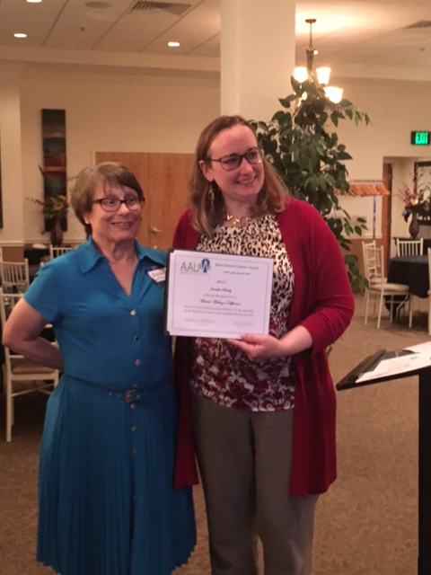
Barbara Lathroum presented the Member Making a Difference Award to Jennifer Schultz.

Jenn for Judge
After the election in November 2016 at least 22,000 women stepped up to run for office at the national, state, and local levels. Jennifer Schultz was one of those women. Jenn has spent the last several months on the campaign trail in her bid for Court of Common Pleas Judge in Philadelphia. Forty-five other Democratic candidates in Philadelphia ran for just nine spots on the November ballot. Jenn originally became an attorney in order “to be a voice for the people who don’t have one.” After ten years of practicing law in the public interest sector, she wondered if she might be more effective as a community advocate in the role of judge in the Court of Common Pleas. She adopted the campaign slogan: ”Bringing the Bench Back to the Community.”

Jenn knew the race would be difficult; she ran two years ago unsuccessfully and lost by 200 votes. Her position on the ballot was 22nd, and her supporters had to remember to pull lever 32 in the voting booth. Jennifer ran her campaign emphasizing this number. Daily she posted to Facebook clever ways to associate the number 32 with her name. One post was: Germanium is an element used in electronics and fiber optics - perhaps most notably in LED technology. The atomic number of germanium is ... 32! Be sure to light up your ballot on May 16 by pressing Button 32! Another post reminded voters: T minus 32 hours until polls open!

The last post listed 32 reasons to vote Jenn for Judge. A very clever campaign! Jenn came in 10th in the Democratic primary but missed a winning position by only 1800 votes! She campaigned hard, and we are all disappointed for her! But Jenn will persist -- if not as Judge, she will find other ways to serve Philadelphia’s community of low income families, She will continue to fight for homeowners threatened with foreclosure, renters about to be evicted, victims of predatory lenders, and consumers whose rights have been violated. Jennifer Schultz will continue to make a difference.

Just one week before this disappointing outcome, the West Chester-Chester County Branch of AAUW honored Jennifer with the “Member Making a Difference Award.” This award is conferred on a member who in a short time has made great contributions to the branch. With Dr tonya thames-taylor, she helped organize and present our first Start Smart workshop for students at WCU. In addition, she gave a workshop on financial literacy to students in our branch affiliate at WCU. For two years, Jennifer designed and organized hands-on activities for girls in grades 5-10 attending the annual Girls Exploring Tomorrow’s Technology workshop. Congratulations Jennifer Schultz! We are so fortunate to have you as a branch member!

Alice Lawson Scholarship
Mimi Jones presented the Alice Lawson Scholarship was awarded to Amanda Carilla at the May banquet.

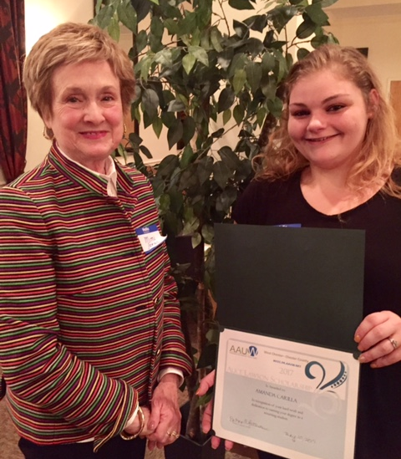

Amanda is a student at West Chester University where she is studying early childhood education. She is the mother of a two year old boy, and one of her goals is to set an example for him, so that he can see the benefits of education. Amanda believes that teaching is a very powerful career choice since it gives you the ability to influence a child in the best possible way.

Amanda works full time as an administrative assistant for Posey Electric Company and has still maintained a 3.5 GPA. She has been on the Dean’s List and the Honor Roll and she plans to graduate in the spring of 2019.

We wish Amanda the best of luck in pursuing her academic goals.

2017-2018 Officers Installed at May Banquet

After Fran Pierce reported from the Nominating Committee, Cathy Palmquist conducted election and installation of officers for the 2017-2018 year.

Barbara Lathroum was joined by Peggy Staarman as Co-Presidents. Mimi Jones and Terry Houle will serve as Program Co-Vice Presidents. Membership was separated into two Co-VPs to serve a two-year term: Patricia Schultz will perform membership accounting, and Phyllis Dunn will carry out membership promotion. Other officers will continue their tenure, including Anne Anderko as Finance Officer and Eva Kaufmann as Recording Secretary.

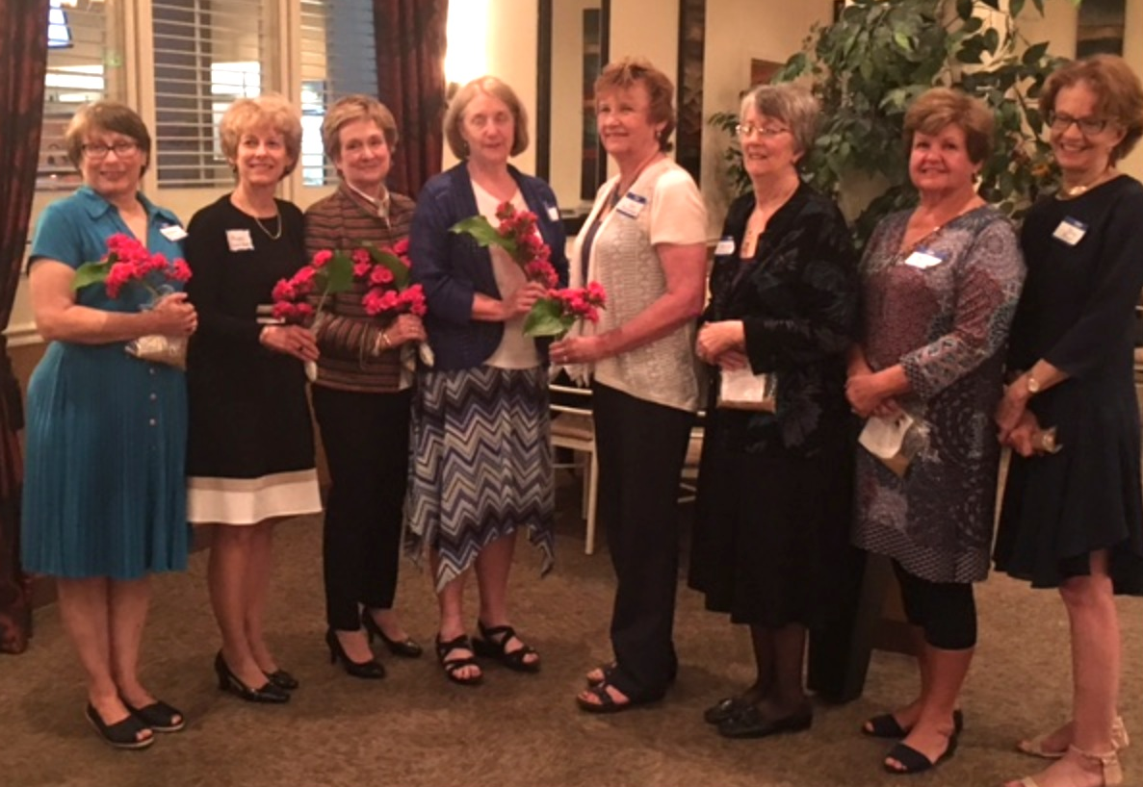
Newly elected officers hold flowers and seed packets presented to them by Cathy Palmquist as symbols of the growth they will foster for the chapter in the coming year.

A Joint Board Planning Meeting of current and new officers will be held May 31 at the home of Barbara Lathroum to plan for the coming year.

Outstanding Women Award Goes to Newsletter Staff
This year’s Award was presented to the AAUWsome News Staff, Toni Gorkin, Norma George, and Nancy Rumfield. Norma commented on the history of the newsletter, and Toni thanked everyone who helped with their contributions.
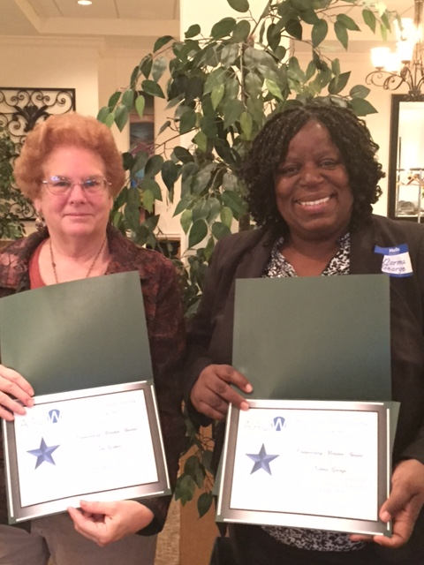
Toni Gorkin and Norma George accept the award on behalf of the newsletter staff.
News from the Laundromat Library League
Arlene Rengert

The number of laundromats with Library Boxes of children's books continues to grow! Among the newest placements are two in the Trenton NJ area (pictured is the E & E laundromat on Greenwood Avenue), a second laundromat in Kennett Square, and the Puentes de Salud clinic for the Latina population of South Philadelphia.

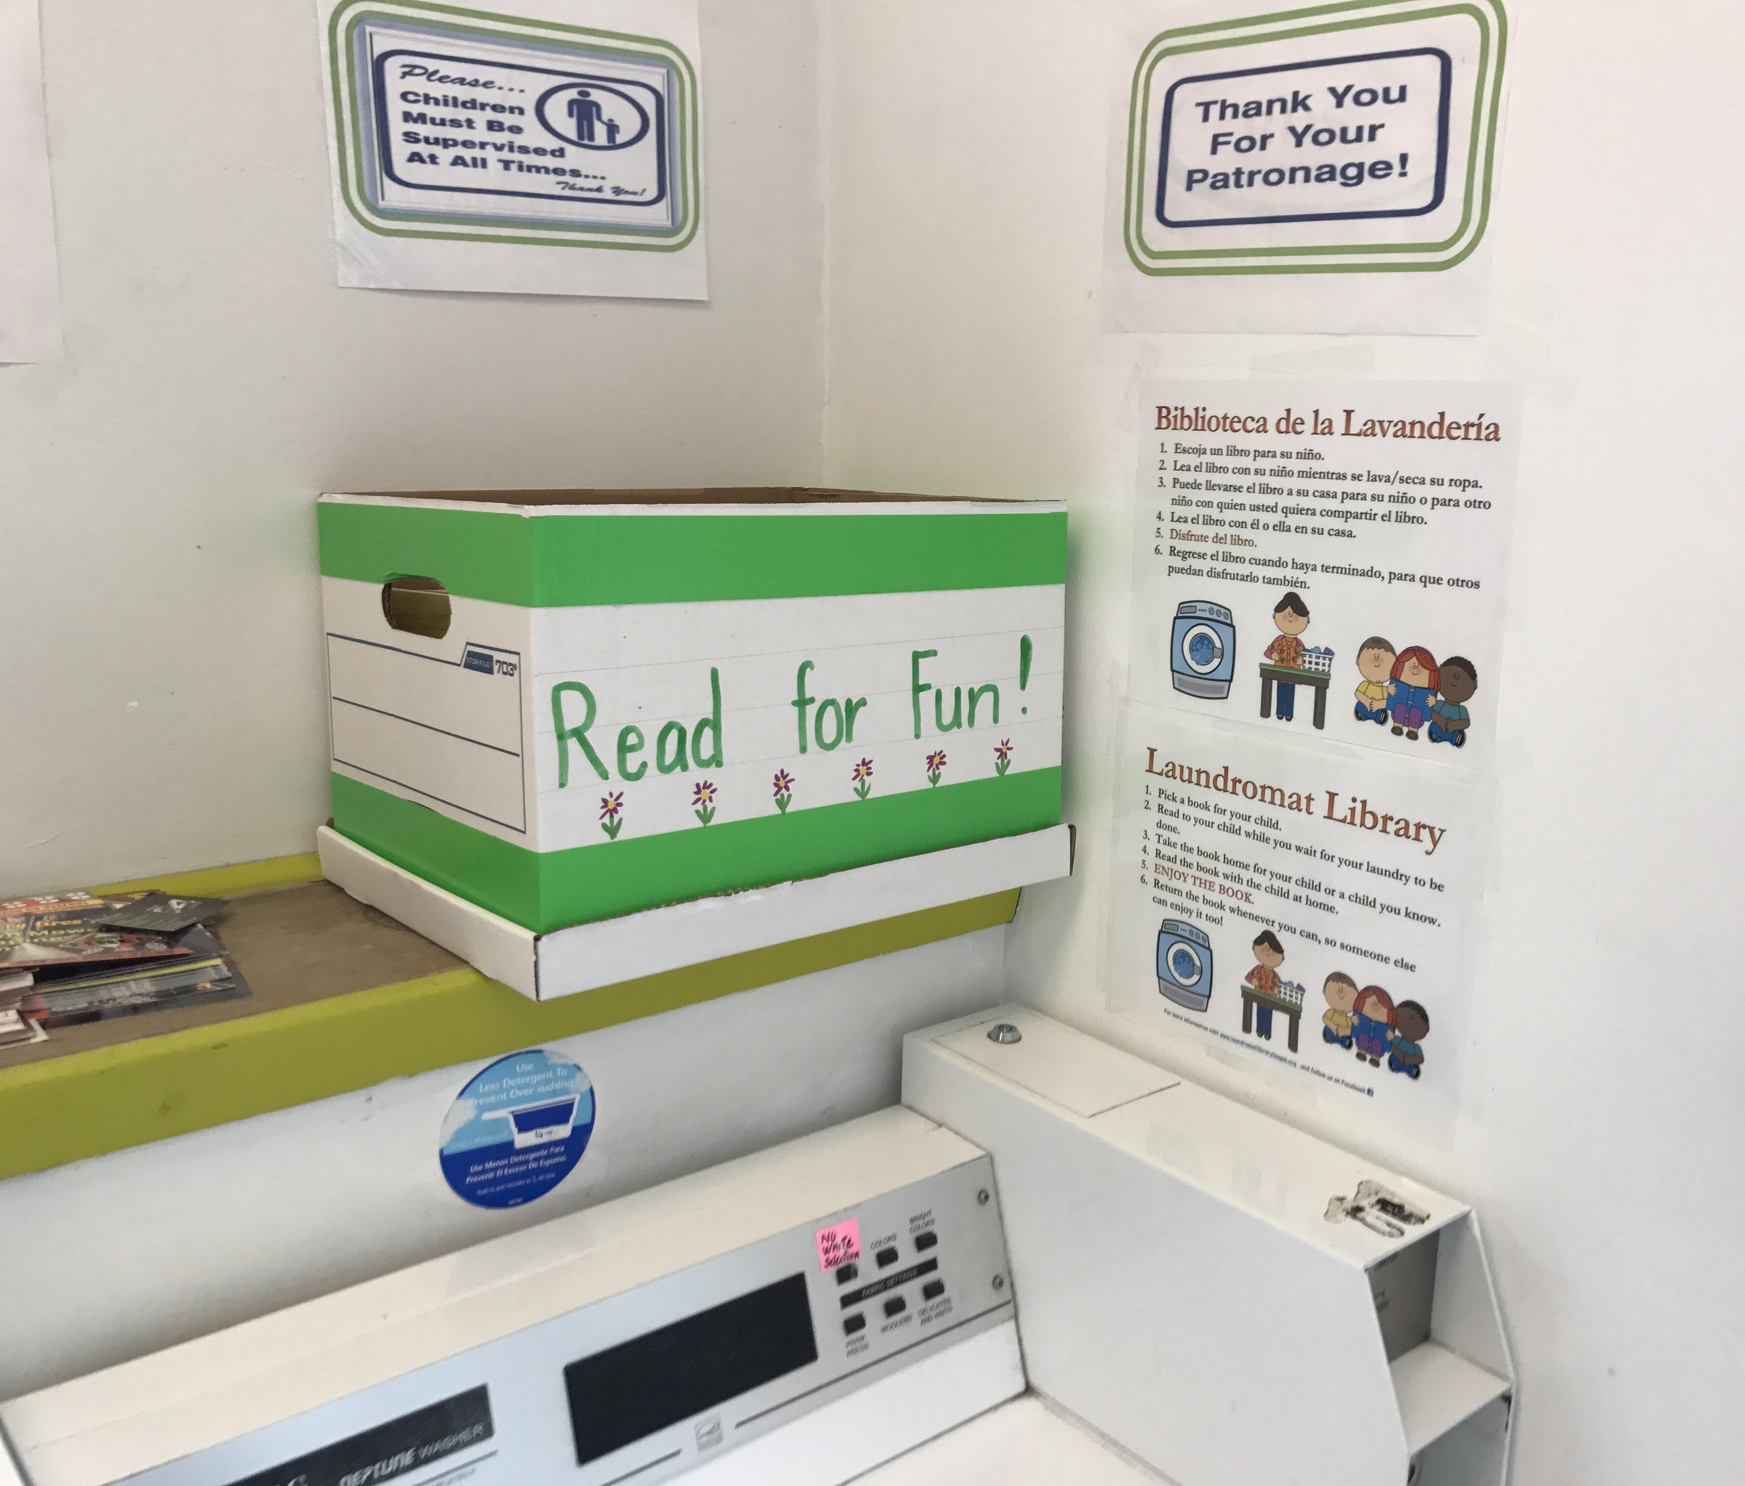

An interactive map that shows the 50-60 placements in Eastern Pennsylvania is on the website www.laundromatlibraryleague.org.
We expect more placements this summer. In mid-June Arlene Rengert will be addressing representatives from several hundred Methodist Churches as the keynote speaker to the annual conference of the Eastern Pennsylvania United Methodist Church, and she will be urging the engagements of laundromats in all localities not yet covered. Arlene also is invited to attend the annual meeting of the Delaware Valley Coin Laundromat Owners Association with a display table, and to meet the national President of that organization who will be there as a speaker.

Our book supply got a boost last May when the Delaware Theatre Company in Wilmington had a children's book drive for us during the run of Hetty Feather; we received 2,080 books (enough to start 38 new laundromats!!). Alas, only one of those was in Spanish.

We have other new initiatives. Soon some of the cardboard Library Boxes will be replaced by wooden ones, thanks to the Eagle Scout project of a member of Troop 6 in West Chester. A local Girl Scout also is constructing some wooden boxes as a project.

Want to be a part of this? Join the over-100 people that are doing single tasks -- some 'stewarding' Library Boxes, others tracking down laundromats by phone and email, others by joining ‘sort and sticker’ sessions to process donated books and create Library Boxes, and still others just by small donations and participating in fundraisers. Be in touch with Arlene Rengert or Terry Houle for ideas of what you can do!!!!

Reminder: The AAUW Action Network (AAUW Action Network advocacy@aauw.org) has been sending out statements about the legislation under consideration in Congress, for example, the American Health Care Act, stating AAUW’s position. These statements provide useful information on the impacts specifically to women and girls by the legislation. You are encouraged to read these emails or read the statements on the AAUW Action Network website and contact your representatives accordingly.

AAUW is communicating concerns around student debt, among other issues, pointing out that women typically emerge from their education with more debt than men.

Time Is Running Out to Vote in the AAUW Election!
Be sure to cast your online ballot in the AAUW National Election by June 15. Decide AAUW’s leadership, whether the membership requirements will change, and more.

Of Local Interest: Opportunities to Get Involved

Meet Our Candidates

A Meet Our Candidates Picnic is being hosted by the Central Chester Co Democrats on Sunday, June 11, from 1:00 to 4:00 p.m. at the East Brandywine Township Community Park, Tara Pavilion, 440 Dilworth Rd., Downingtown. You are invited to meet local Democratic candidates, including:
Patricia Maisano for Chester County Treasurer, Margaret Reif for Chester County Controller, Christina VanderPol for Chester County Coroner, Maria Crossan for Chester County Clerk of Courts. Note how many women are emerging as candidates. The picnic is not a fund raiser but donations are being accepted for the Domestic Violence Center of Chester County.

Local Emergency Activist Response Network Forming in Chester County to Fight Hate

Chapter member Cathy Palmquist has passed information along about this effort after attending the first organization meeting in April, called by the YWCA, at which a group of concerned Chester County discussed creating a network to combat acts of hate and injustice locally. The YWCA is hosting two more organizing meetings to discuss how people can come together under their working mission. The second meeting was held June 1 at the West Chester Borough Hall.

The third organizational meeting will be held on Thursday, June 15, 6:00 to 7:30 p.m., at the Coatesville Area Public Library – Community Room, 501 Lincoln Hwy, Coatesville, PA.

You can view the YWCA page www.ywcade.org/actionresponsenetwork to find out more about the model and similar networks that have been formed under facilitation of YWCA. More information can be obtained from the YWCA Delaware Director of Racial & Social Justice, Matt Pillischer, at mpillischer@ywcade.org.
AAUW Mission Statement
AAUW advances equity for women and girls through advocacy, education, philanthropy, and research.

Norma George Newsletter Co-Editor
610-872-7567 ngeorge@cheyney.edu

Nancy Rumfield Newsletter Co-Editor
610-399-0388 nrumfield@gmail.com

Toni Gorkin Newsletter Co-Editor
610-363-7627 tgorkin@comcast.net

Newsletter email aauwsumnews@gmail.com

Barbara Lathroum Branch President
610-321-9783 blathroum@gmail.com

Mimi Jones Program Vice-President
610-269-9162 Danandmimi1@verizon.net

Peggy Staarman Membership Vice-President
610-269-4866 peggstaar@verizon.net
Eva Kaufmann Secretary
610-793-3809 ekaufmann1@gmail.com

Anne Anderko Financial Officer
484-885-4943 ananderko@msn.com

Branch Website wccc-pa.aauw.net

Guidelines for AAUW some

1. Deadline for articles is the 10th of the month prior to publication – e.g., October 10, December 10, January 10, etc.

2. Board will develop outline/plan for newsletter.

3. Copies of each newsletter article must be sent to the President and the President Elect.

4. Articles should be less then 340 words (1 column in 12 pt.) and sent as .doc (Word) files whenever possible.

5. Program information should be available for publication in the month prior to the event.

6. SIG information should be specific (when, where, leader, contact info., program or book).

7. Photos should be sent in .jpg format and should be the best quality possible. Leave cropping to the editors when possible. Be sure to provide names of the people and description of the happening in the photo.
8. Editors must keep newsletter to 10 pages or less (5 printed front and back).

9. Editors must consult with President or designee if newsletter is too long.

10. Editors and President will determine number of copies to be printed.

11. Board will review and decide list of Friends who receive printed copies.

12. The newsletter should go to the printer by the 25th of the month. Copies should include the Circulation Manager, Person who distributes the e-mail version, and, if requested, other named designees.

Interested in submitting an article or have information to share?

We need your News!

The co-editors of AAUWsome News are

delighted to bring you this issue of the

newsletter, but … We continue to need input

from members!! Please send articles as Word

documents. Forward your news articles to the

gmail account: aauwsumnews@gmail.com,

indicating the topic and month in the subject

box and cc the President. This is a shared

account, so the co-editors can access your

email and keep their work or personal

mailboxes from getting filled. It also makes

collaborating easier.

Remember that articles for a given month of

the newsletter are due on the 10th of the

preceding month. Please provide all necessary

information with your submission.

Two Minute Activist

Don’t forget your commitment to be a frequent
Two Minute Activist. Make your voice heard in
Congress regarding education, economic security,
and civil rights. Using our website (under AAUW
Links) is so easy!

Note: AAUW (and numerous other organizations we may belong to, such as National Audubon Society and Sierra Club) are making it easy to send letters to your senators, using links on their websites and pre-authored sample letters expressing opinions about issues at the forefront today. Be sure to check the websites of your favorite organizations.
Membership News
Peggy Staarman (Vice President for Membership)

Carol Haaf is the newest member of our West Chester-Chester County Branch. Carol retired from her position as Manager of Research in the IT Department of DuPont. She is a board member of SCC United Way and a Pocopson Committee Person. She enjoys piano, crafts, reading, and hiking. I know you will welcome Carol at our September meeting and encourage her to join our many projects and activities.

Please remember to renew your membership. A seasoned procrastinator, I usually wait to the last minute to attend to due dates, project deadlines, and other time-related issues. However, it is very helpful to Anne Anderko and me to receive your membership form and check before June 30, the expiration date of your present membership. Please send your form and check to me (307 Benning Lane, Downingtown, PA 19335) or to Anne (908 Pine Valley Circle, West Chester, PA 19382). If you have any questions about your membership, please contact me (peggstaar@verizon.net). Thank you so much!

Membership Outreach

Your Records with the National Association can be accessed by contacting:
--Helpline Phone (800) 326-2289 or
--Internet and email: The website for national AAUW is http://www.aauw.org/.
You’ll need your membership number, which can be found on the address label of the Association publication (Outlook).

Board Meetings

A Joint Board Planning Meeting of previous and new officers will be held May 31 at the home of Barbara Lathroum.

Member Special Notes

The newsletter editors continue to include news about our AAUW chapter members in this newsletter.

Many of our members are involved in other projects that also support women’s issues, support our community, or express their passion and creativity. This is an opportunity to tell us what you are doing, and where appropriate, to share involvement. Please see the AAUW some guidelines for sending your articles and information to the newsletter’s gmail account --aauwsumnews@gmail.com.

Women in Politics
Peggy Staarman

There is excitement in Chester County because of the number of women who are running for County Row Offices. On the Democratic ticket, Patricia Maisano is running for County Treasurer, Margaret Reif would like to be the next County Controller, Dr. Christina VandePol is running for County Coroner, and Maria Crossan is vying for the office of County Clerk of Courts. On the Republican roster is the incumbent Robin Marcello who would like to retain her position as County Clerk of Courts. Please research the positions of these women and support the campaigns of your chosen candidates.

To elect your candidates, you need to address voter turnout. Many of us are concerned with the low registered voter turnout in our recent Primary Election. Although Democratic participation increased as a percentage of the overall voter turnout, the percentage of registered voters who exercised their franchise was disappointing. The overall voter turnout for our county was 14.36 % (17.93 % registered Democratic voters, 16.89% Republican). However, Uwchlan 2, my precinct, had a total turnout of 6.58%, Uwchlan 6 had a total turnout of 8.79%, and Uwchlan 7’s was 7.37%. These results were among the lowest in Chester County. (The statistics were provided by Chester County Voter Services.)
Please contact and work with your AAUW members, your political party, the League of Women Voters, your Huddle, Chester County Voter Services, and your neighbors to help “Get Out the Vote.”

Marches for Science, Climate
Rachel Snyder (left) and Toni Gorkin (center) were among several AAUW members who attended the Climate March in West Chester on Saturday, April 29. Rep. Carolyn Comitta, also an AAUW member, Jordan Norley, mayor of West Chester, mayoral candidate Dianne Herrin, and congressional candidate Chrissy Houlihan spoke to an audience of about 200. They described the progress West Chester has made in supporting green energy practices and stressed the importance of grass-roots action. The event was for people who wanted to demonstrate their support of the environment but were unable to attend the march in DC.

Toni also attended the March for Science in Philadelphia on April 22. With her participation she expressed the importance of science to the well-being of our democracy and showed that women are playing an important role not only in the scientific field but also in the political action to make ALL of our representatives, no matter what party, aware that a great number of American citizens support climate change and scientific research.

Nancy Rumfield to Exhibit Art

Nancy Rumfield will exhibit artwork with several of her colleagues at the Blue Streak Gallery at 1721-1723 Delaware Avenue, Wilmington, June 2-17. An artist reception will be held June 2 from 5-8 p.m.

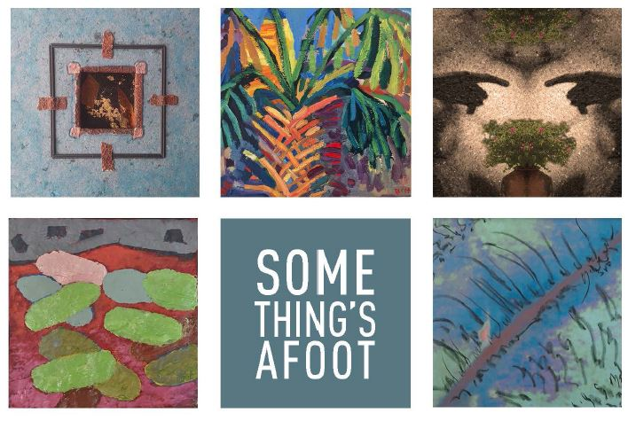
Women Willpower - A New Women’s Resource
Cathy Palmquist

Cathy reports she recently attended a most interesting meeting of a new women’s group forming in West Chester. The Inaugural Summit of Women Willpower was held recently at the Uptown! Knauer Performing Arts Center in West Chester. Women Willpower has a long-term goal of women supporting women by harnessing women’s collective leadership power. Women Willpower will serve women who consider themselves to be leaders, such as women in small business, in the community, entrepreneurs, and those who aspire to lead.

At its inaugural meeting, 10 women spoke at three workshops on three issues: time, growth, and trust. Speakers included a wealth consultant, higher education consultant, marketing strategist, environmentalist, professional services trainer and coach, founder of a non-profit, artistic director, partner in a law firm, arts administrator, an artist and a physical therapist. A TED talk segment was shown at each of the three workshops, prior to participants breaking into small groups to discuss each issue.

For additional information about this fledgling group: www.womenwillpower.com.

Special Interest Groups

Couples Bridge
A chair is needed. Please contact Barbara Lathroum blathroum@gmail.com if interested.

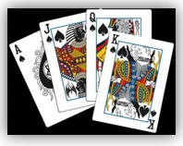

Women's Social Bridge
Calling all bridge players! Women's Social Bridge will meet on June 16, July 28 and August 25. We have had two tables the past two months and hope to continue the trend! Some of us will be on vacation for some dates, so this is the perfect time to come out and give us a try! Contact Sandy Alexander at frau.salexander@gmail.com to get our emails!

Book Groups:
AAUW branches are known for their book groups, and membership in a group often encourages continuing membership. The West Chester-Chester County Branch currently has two book discussion groups meeting in the day and in the evening at different times of the month.

LIT I: Daytime Literature Group –
Fiction & Nonfiction Book Group- Kay Phillips- khp65hp@verizon.net

Our daytime Literature group meets the third Monday of the month at 1:00 p.m. for refreshments followed by discussion beginning at 1:30 p.m. We read both fiction and non-fiction.

We are a daytime Lit Group and welcome others to join us. Please let your hostess know if you plan to attend. Our last meeting for this year will be held on Monday, June 19th at 5:00 pm.at Kay Philipps house. Please bring a salad to share and your suggestions for fiction or non-fiction books to discuss starting in September 2018. We will choose our books, discussion leaders and hostess's for the year. New members are welcome. Please let Kay know if you will be joining us on the 19th.Phone 610-399-0697 or e-mail Khphilipps@verizon.net.

Questions? Call or e-mail Kay Philipps, Chair, at (610) 399-0697 or khphilipps@verizon.net.

LIT II: Evening Literature Group –
Literature II - Fiction & Nonfiction Book Group -Jean Speiser - JeanSpeiser@gmail.com

Focusing on fiction with occasional non-fiction thrown in, Literature II meets on the third Wednesday of each month for lively and often opinionated discussion.

We always welcome new members. Snow and some of our members' schedules have brought about a change in our May plans.
Lit II will have our annual potluck on Wednesday June 21 (note date change) at 6:00 p.m. at the home of Fran Pierce; that’s when we select the coming year’s books, so start thinking about recommendations (make sure your recommended book is easily available in paperback, ebook, or the Library).

FIG (Food Interest Group)
This group dines around either at a member’s home or at a restaurant. The group usually meets on a Saturday for dinner or Sunday for brunch on a monthly or bi-monthly basis. Couples (unless otherwise specified) and singles, as well as new members, are welcome.

Next event: Saturday, June 24th at 6:30pm –Dinner out at Ruchi Authentic Indian Cuisine in Exton, hosted by Jennifer Schultz. Invitations will be emailed to FIG members, but all branch members and significant others are welcome. For more information or to join the group, contact Donna Eaves, #610-692-5277, or deaves@live.com.

We are looking for members who would like to host or plan a meal at a restaurant in the upcoming months. Please contact Donna if you are interested.

Great Decisions
For information contact Jacky Page at 610-359-9887 or jacquelinepage9@gmail.com

TIG (Travel Interest Group)
The Travel Interest Group is composed of members and their guests who like to go to interesting places and often enjoy a meal together before or after. We usually do something 7 or 8 times a year.

Also, please contact Barbara Lathroum if you want to be on the list for future events. Being on the list does not obligate you to attend any trips. Anyone is welcome to coordinate an event or trip they are interested in. Examples are historic house tours, museums, interesting collections (e.g., we enjoyed a collection of women’s costumes in 19th century Chester County at the Chester County Historical Museum).

Needlework Group:
This group includes all forms of needlework – knitting, crochet, embroidery, applique, quilting, needlepoint and any other needlework members would like to share. A schedule of meetings is being prepared. Contact Barb Lathroum if interested.

402 Edgewood Drive, Exton, PA 19341.

June 2017 Newsletter
wccc-pa.aauw.net

AAUW Mission Statement
The AAUW advances equity for women and girls through advocacy, education and research.
AAUW Vision Statement
AAUW will be a powerful advocate and visible leader in equity and education through research, philanthropy, and measurable change in critical areas impacting the lives of women and girls.

AAUW West Chester – Chester County Branch Vision Statement

The West Chester-Chester County Branch will
- Actively recruit members who support Association goals.
- Nurture these members through active Interest Groups, through monthly meetings with
intellectual and social merit, and through member support.
- Sponsor at least one project per year with volunteers and with funds to promote Association and branch goals.
- Sponsor at least one local scholarship per year for a nontraditional student
- Support programs for training and self-development of branch members to promote
Association goals.
- Raise funds through community projects and member gifts to support Association goals.
**********
Since its first meeting in 1881, AAUW has been a catalyst for change. Today, with more than 100,000 members, 1,000 branches, and 500 college and university partners, AAUW contributes to a more promising future and provides a powerful voice for women and girls—a voice that cannot and will not be ignored.
www.aauw.org www.aauwpa.org wccc-pa.aauw.net

