Mary Pinkney (1914-2019)

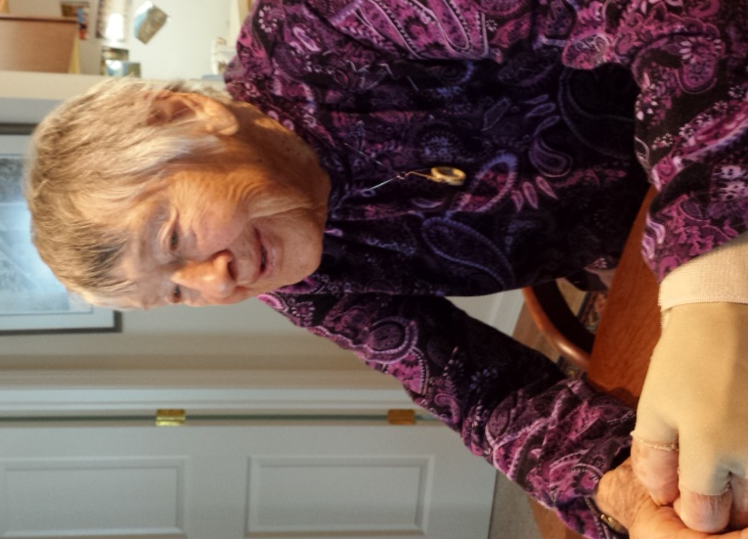
Mary Pinkney, a long-time member of our branch, passed away on Monday, December 9th. Last spring we were happy to celebrate Mary's 105th birthday.

Mary was born in 1914 in Louisville, Nebraska, attended Central High School in Omaha, then the University of Nebraska in Lincoln. She transferred to University of Illinois to study City Planning. There she was taught chemistry by her future husband, Paul Pinkney. After their marriage, they moved to Wilmington, DE where he did research at the DuPont Experimental Station, eventually moving to DuPont facilities in Niagara Falls, NY and Memphis, TN.
After their three children were grown, Mary earned a graduate degree in English Literature from the University of Buffalo before Paul was transferred back to Wilmington. They moved to Westtown, PA around 1965, and Mary taught English at both high school and college levels.
When Mary’s husband Paul bought one of the first Windsurfers on the east coast and taught himself board-sailing, Mary became an expert teacher. They traveled together to many Windsurfer World Championships, and in her 60s, Mary won first place in the Women’s Master Class in the 1981 Windsurfer World Championships in Japan.
Speaking about her summer at the age of 102, Mary told Eva Kaufmann about her recent travels, including a cruise in the North Sea and Baltic, followed by a bus tour of the UK. She had also spent time with her family by a lake in New York. She complained of some bruises, and when asked how she had gotten them, she replied that she had slipped while getting out of the canoe!
Mary was a member of this AAUW branch since 1968. She was very active in AAUW, as well as in the community, advancing equity for women through advocacy, education, philanthropy and research. She wrote biographies of West Chester area women of note for “Pennsylvania Women in History, Our Hidden Heritage,” published in 1983 by the Pennsylvania Division of AAUW. Her branch activities earned her an Outstanding Woman award, and she was twice recognized with a Named Gift to the AAUW Educational Foundation. Until last year she participated in the Lit I group, leading discussions, drawing on her many travels and extensive reading to bring new meaning to the books.

