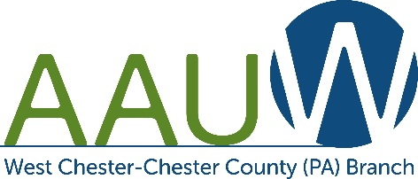
ALICE LAWSON SCHOLARSHIP
GENERAL INFORMATION
2021-2022

The West Chester-Chester County PA Branch of the American Association of University Women is offering a $1,500 academic scholarship* to a deserving student meeting the following requirements. The scholarship will be applied toward tuition expenses for the upcoming 2021-2022 academic year. The application deadline is March 31, 2021. All applications must be received on or before this date. You will be notified of the results by the beginning of May.
Requirements
- A scholarship recipient must:
  - Be a full- or part-time undergraduate woman who has completed at least
60 semester credits prior to the spring semester of 2021
  - Be at least 25 years old
  - Be enrolled for the 2021-2022 academic year at a four-year college or university
  - Reside in Chester County or attend a school in Chester County
  - Have a GPA of at least 3.0 (out of 4.0)
- Completed application requirements:
  - Recommendation from a professor using the AAUW required form (Additional letter is optional.)
  - Official transcripts of undergraduate work from all colleges and universities attended. May be issued to the student, but must be an official copy
(unopened) from the Registrar’s office
  - If not a U.S. citizen, copy of permanent residency document required.
To apply:
- Download application form from wccc-pa.aauw.net/scholarships/alice-lawson/ and save completed form with AAUW 21-22 and your name in the filename.
- Send one email with completed application and any supporting documentation to liczwek@gmail.com.
- Provide your professor with a printed or electronic copy of the recommendation form. Have them send it to the address below or email it to liczwek@gmail.com.
- Mail transcript to: AAUW Scholarship Coordinator
Deborah L. Liczwek
600 Swallow Lane
West Chester, PA 19380-1945
For questions, please contact the scholarship coordinator Deb Liczwek at liczwek@gmail.com.

NOTE: Incomplete applications or applicants who do not meet the above requirements will not be considered.

