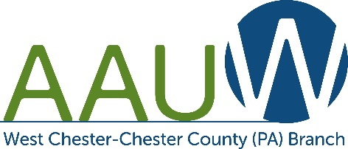
ALICE LAWSON SCHOLARSHIP

LETTER OF RECOMMENDATION

The West Chester-Chester County PA Branch of the American Association of University Women is offering a $3,000 academic scholarship to a deserving non-traditional student. The scholarship will be applied toward tuition expenses for the 2022-2023 academic year.

Please fill out this Letter of Recommendation for your student and mail it to the below address. Application deadline is March 31, 2022.

AAUW Scholarship Coordinator
Jane Schultz
1300 Amstel Way
West Chester, PA 19380-5818

Student’s name:

Evaluator’s name and position:

Office phone number:

How long have you known the student?

How do you know the student?

Please rate the student:
 | Poor  1 | Average  2 | Good  3 | Exceptional  4
Initiative
Motivation
Reliability
Creativity
Intellectual abilities
Leadership
Communication skills

Please state why student deserves this scholarship. (May continue on next page):

SIGNATURE:

DATE:

