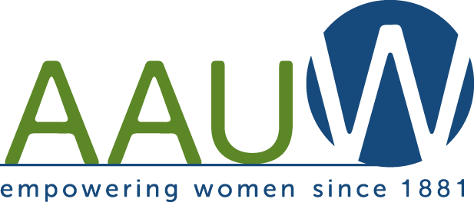
2022-2023 Membership Form – Renewal

West Chester-Chester County Branch

AAUW is a non-profit, non-partisan organization with a nationwide network of ~1,000 local branches that partner to advance equity for women and girls through advocacy, education, philanthropy, and research.

______________________________________________________________________________________________________________________________
Please complete and return this form with your dues.
If there is anything that you wish to be kept confidential, please add a comment regarding that item.

Name ____________________________________________________ Date__________________

[ ] There are no changes since last year [ ] See changes indicated below:

Preferred first name for handbook (if different from above) __________________________
Name of Spouse/Partner (if you choose to include him/her in handbook) __________________________________

Address______________________________________________________________________________________

City________________________________State______Zip____________Voting Township__________________

Telephone (please star if you have preferred number) [home]_______________________[cell]_______________________

e-Mail_______________________________________________________Birthday ______/______/____________
YEAR OPTIONAL

Occupation/Title/Company _________________________________________________Active? [ ] Retired? [ ]

______________________________________________________________________________________________________________________________

*****PLEASE COMPLETE THIS SECTION*****

CHECK MEMBERSHIP LEVEL

Regular Membership (National $67, State $10, Branch $16) $93.00 [ ]
National Paid Life Membership (National $0, State $10, Branch $16) $26.00 [ ]
Honorary Life (50 Years) Membership (National $0, State $0, Branch $0) $ 0 [ ]

Please make check payable to: AAUW – West Chester-Chester County

Return Form and check to: Inquiries to:
Trish Alfano Kim Glavin
Co-VP Membership Co-VP Membership
1004 Pine Valley Circle, West Chester, PA 19382 306 Spindle Lane, West Chester, PA 19380
610-431-4545 484-354-9681
BA1004@comcast.net kimglavin@comcast.net

****PLEASE ALSO COMPLETE AND RETURN PAGE 2: ACTIVITIES, INTEREST GROUPS & PROJECTS FORM****

Name ______________________________________________________________________________________

Volunteer Experience/Community Activities?______________________________________________________

_______________________________________________________________________________________________________________

Hobbies?____________________________________________________________________________________

Do you have computer experience? Website design [ ] Database [ ] Desktop Publishing [ ]
Word/Excel [ ] Other __________________________________

REQUEST MORE INFORMATION ON ACTIVITIES, INTEREST GROUPS AND PROJECTS

Groups: | Please Check | Comments
Alice Lawson Scholarship Fund
Annual Handbook
Book Club 1 – 3rd Monday, 1PM
Book Club 2 – 3rd Wednesday, 7:00PM
Book Club 3 – 1st Tuesday, 1PM
Branch Facebook Page
Branch News & Publicity
Branch Website
Bridge – 3rd Friday, 10AM
Community Outreach Programs
Food Interest Group (FIG)
Fundraising
GETT (Girls Exploring Tomorrow’s Technology)
Great Decisions (discussion group)
Historian
Hospitality
Laundromat Library League (LLL)
Legislation & Public Policy (LAPP)
Mah Jongg – 1st Thurs 7PM & online 3rd Thurs 7PM
Membership
Newsletter Publication
Nominating Committee
The Stitchers – Weekly Thursday 10AM
Travel Interest Group (TIG)
Walkers – Weekly Tuesday 9AM
OTHER INTEREST IDEAS THAT YOU MIGHT SUGGEST

