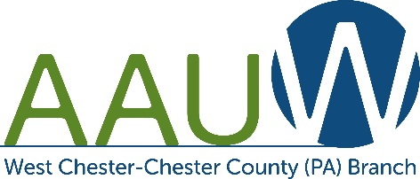**ALICE LAWSON SCHOLARSHIP**

**LETTER OF RECOMMENDATION**

The West Chester-Chester County ***Alice Lawson academic scholarship*** is awardedto a non-traditional student. This scholarship will be applied toward tuition expenses for the 2025-2026 academic year.

Kindly fill out this **Letter of Recommendation** for your student and email it as an attachment to the below email address. Place *Alice Lawson Scholarship* in the subject line. Application deadline is **March 31, 2025.**

**AAUW Scholarship Coordinator**

**suzydegeorge@yahoo.com**

**Student’s name:**

**Evaluator’s name and position:**

**Office phone number:**

**Office email:**

**How long have you known the student?**

**How do you know the student?**

**Please rate the student:**

|  |  |  |  |  |
| --- | --- | --- | --- | --- |
|  | **Poor**  **1** | **Average**  **2** | **Good**  **3** | **Exceptional**  **4** |
| **Initiative** |  |  |  |  |
| **Motivation** |  |  |  |  |
| **Reliability** |  |  |  |  |
| **Creativity** |  |  |  |  |
| **Intellectual abilities** |  |  |  |  |
| **Leadership** |  |  |  |  |
| **Communication skills** |  |  |  |  |

**Please state why student deserves this scholarship. *(May continue on next page):***

|  |  |
| --- | --- |
| **SIGNATURE:** |  |

|  |  |
| --- | --- |
| **DATE:** |  |