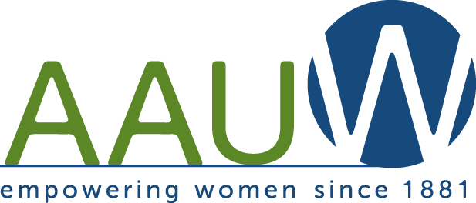
2025-2026 Membership Form – Renewal

West Chester-Chester County Affiliate

AAUW is a non-profit, non-partisan organization with a nationwide network of ~1,000 local affiliates that partner to advance equity for women and girls through advocacy, education, philanthropy, and research.

______________________________________________________________________________________________________________________________
Please complete and return this form with your dues.
If there is anything that you wish to be kept confidential, please add a comment regarding that item.

Name ____________________________________________________ Date__________________

[ ] There are no changes since last year [ ] See changes indicated below:
Please do not check the “no changes” box and then add information below. Check EITHER box. Enter only CHANGES below.

Preferred first name for handbook (if different from above) __________________________
Name of Spouse/Partner (if you choose to include him/her in handbook) __________________________________

Address______________________________________________________________________________________

City________________________________State______Zip____________Voting Township__________________

Telephone (please star if you have preferred number) [home]_______________________[cell]_______________________

e-Mail_______________________________________________________Birthday ______/______/____________
YEAR OPTIONAL

Occupation/Title/Company _________________________________________________Active? [ ] Retired? [ ]

______________________________________________________________________________________________________________________________

*****PLEASE COMPLETE THIS SECTION*****

CHECK MEMBERSHIP LEVEL

Regular Membership (National $74, State $12, Affiliate $16) $102.00 [ ]

Designated National Paid Life Member (National $0, State $12, Affiliate $16) $28.00 [ ]

Honorary Life (50 Years) Member (National $0, State $0, Affiliate $0) $ 0 [ ]

Please make check payable to: AAUW – West Chester-Chester County

Return Form and check to: Inquiries to:
Karen Marshall Susan Woron
Co-VP Membership Co-VP Membership
920 Shiloh Road, West Chester, PA 19382 207 Chandler Drive, West Chester, PA 19380
610-316-9325 484-467-6705
karenrory@comcast.net sworon54@gmail.com

****PLEASE ALSO COMPLETE AND RETURN PAGE 2: ACTIVITIES, INTEREST GROUPS & PROJECTS FORM****

Name ______________________________________________________________________________________

Volunteer Experience/Community Activities?______________________________________________________

_______________________________________________________________________________________________________________

Hobbies?____________________________________________________________________________________

Do you have computer experience? Website design [ ] Database [ ] Desktop Publishing [ ]
Word/Excel [ ] Other __________________________________

REQUEST MORE INFORMATION ON SIGNING UP FOR ACTIVITIES, INTEREST GROUPS AND PROJECTS

Groups: | C for continued/  N for new interest | Comments:
Scholarship Funds: Alice Lawson (tuition only)
Scholarship Funds: Mimi Jones (supplemental funds)
Annual Handbook
Book Club 1 (aka LIT I) – 3rd M of month, 1PM
Book Club 2 (aka LIT II) – 2nd M of month, 2PM (not Dec.)
Our Facebook Page
Our News & Publicity
Our Website
Bridge – 3rd Friday, 10AM
Community Outreach/Gateway to Equity
(recipient awarded annually; ask for details)
Community Warehouse
Food Interest Group (FIG)
Fundraising
Great Decisions (discussion group)
Historian
Hospitality
Laundromat Library League (LLL)
Legislation & Public Policy (LAPP)
Mah Jongg – 1st and 3rd TH of month, 1PM
Membership
Newsletter Publication
Nominating Committee
Travel Interest Group (TIG)
Walkers – Weekly Tuesday 9AM
West Chester Food Cupboard – Last M of month, 7PM
OTHER INTEREST IDEAS THAT YOU MIGHT SUGGEST

